Name _______________________________________

Controlling Light | Shutter Speed + Aperture | Study Guide

To make a correct exposure, so that your picture is neither too light nor to dark, you need to control the amount of light that reaches the digital image sensor.

Shutter Speed = Exposure Time
The shutter speed (the amount of time the shutter remains open) is one of two controls your camera has over the amount of light entering the camera.
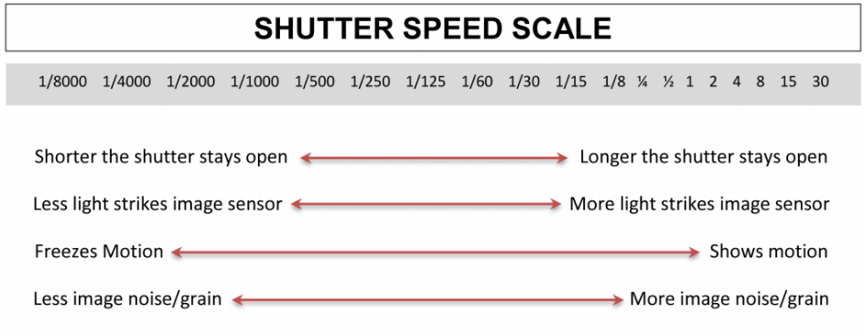

Aperture = f-Stop
The aperture size is the other light control (how big or small is the hole that allows light in the camera).
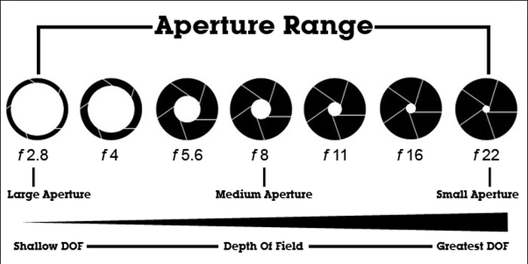

By controlling the amount of light that enters the camera, the shutter speed also affects the way that moving objects are shown.

A fast shutter speed can freeze motion–1/250 sec. is more than fast enough for most scenes. A very slow shutter speed will record even a slow-moving object with some blur.

Shutter Speed + Aperture

The shutter speed and aperture work to together to achieve a correct exposure. As the shutter speed gets faster, letting less light hit the sensor, the aperture opening gets larger to make up the difference. If you want to use a small aperture opening, the shutter speed will become slower to compensate. For a correct exposure the shutter speed and the aperture opening need to work together to allow the correct amount of light strike the sensor.

Aperture – F-stop
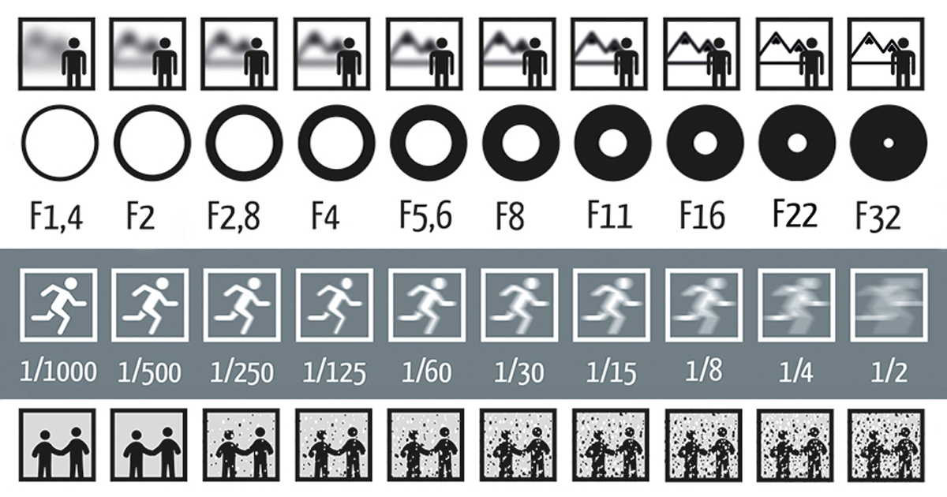
Shutter Speed

1. Which photograph below best illustrates a fast shutter speed?
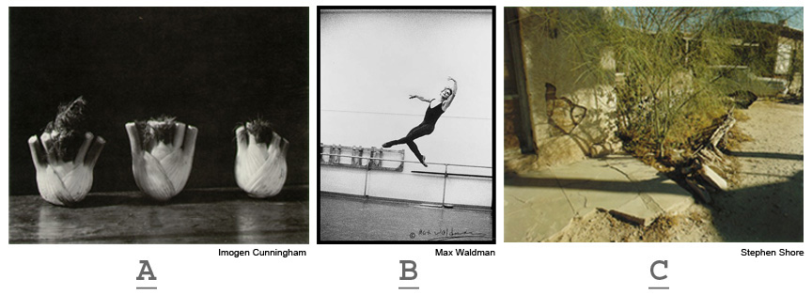

2. Which photograph below best illustrates a fast shutter speed?
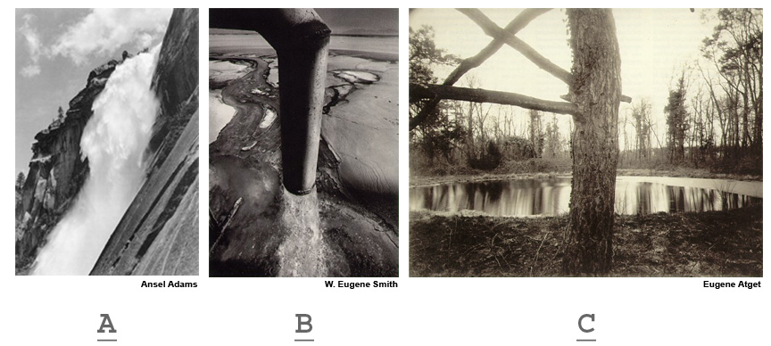

3. Which photographs below best illustrates a slow shutter speed?
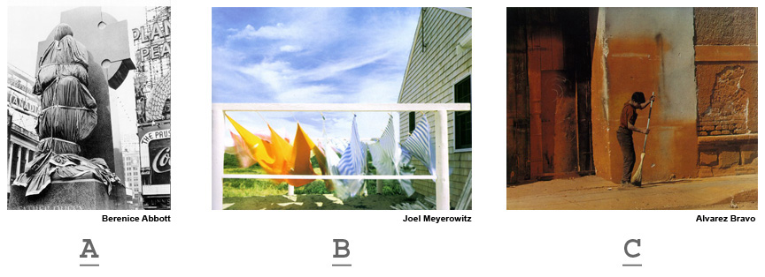

4. Which photograph below best illustrates a slow shutter speed?
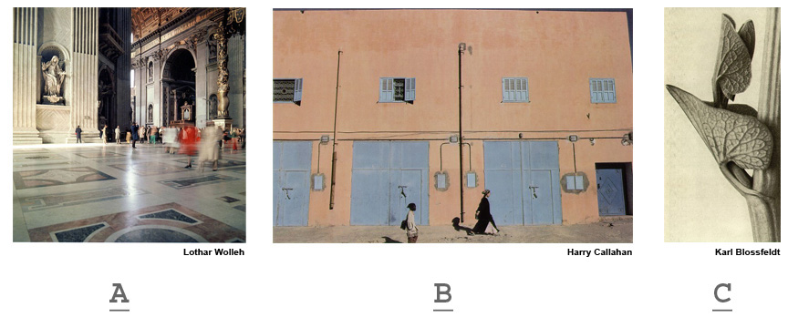

5. Which photograph below best illustrates a large aperture opening?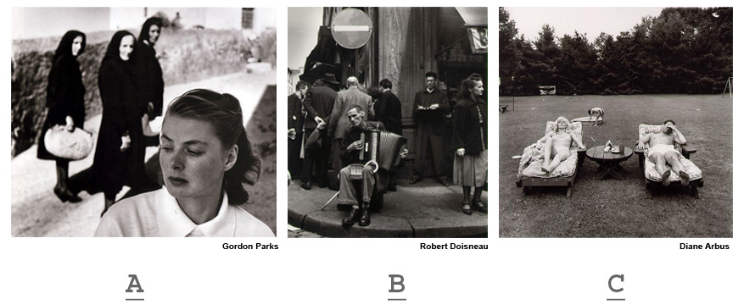

6. Which photograph below best illustrates a large aperture opening?
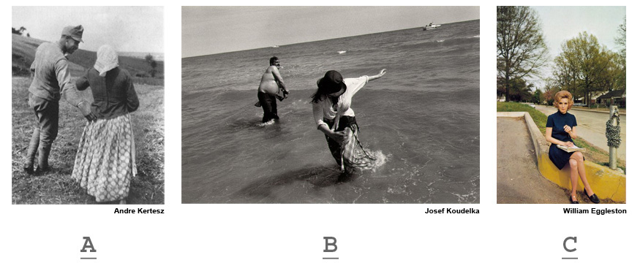

7. Which photograph below best illustrates a small aperture opening?
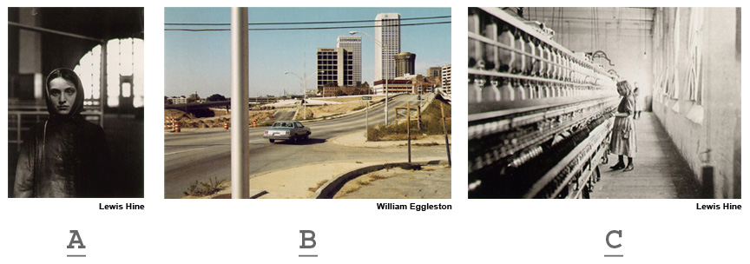

8. Which photograph below best illustrates a small aperture opening?
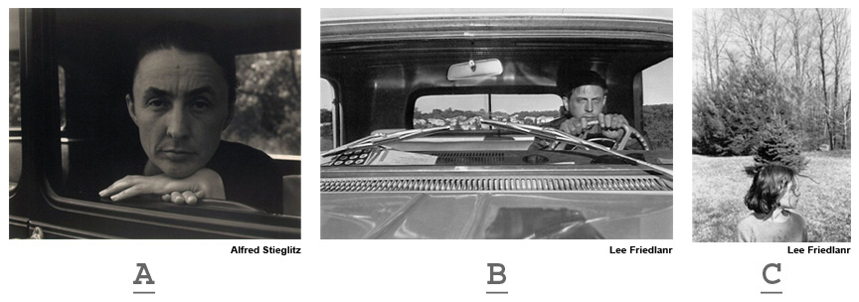

9. Which of the following photographs best illustrates a fast shutter speed with a large aperture opening?
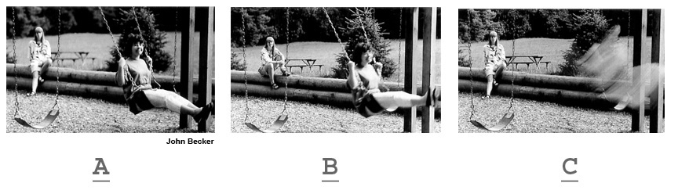

10. Which of the following photographs best illustrates a slow shutter speed with a small aperture opening?
